# Question 1

a) The fetch-Decode-Execute cycle is the computer getting the instruction from a file, changing it into machine code so the computer itself can understand and then execute what the instructions says for them to do. The fetch gets the instruction from a specific area. It does not automatically understand what the instruction means for them so it changes it all into ones and zeros. It then reads the ones and zeros line by line. After reading each line it immediately executes the instruction just read. That is the Fetch-Decode-execute cycle

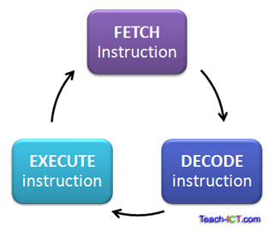

b) The von Neumann Architecture is a computer design model that uses a single storage structure to hold both instructions and data. Instead of executing the programme as it was entered, it instead stored the programmes in memory which allowed it to be used for later purposes. This was what the von Neumann Architecture allowed.

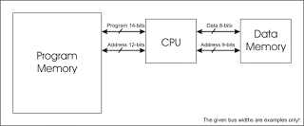

c) i) The Pigeon Hole represents the storage area with the little man (OS) itself and all the instructions locations

ii) The in-tray represents all the data and work the little man (OS) must do that day.

iii) The program counter represent which the instruction the little man (OS) is on, as a reminder to itself.

iv) The calculator is used for temporary storage and doing calculations for the computer itself

v) The out tray represents all the results the little man (OS) has gotten from his work.

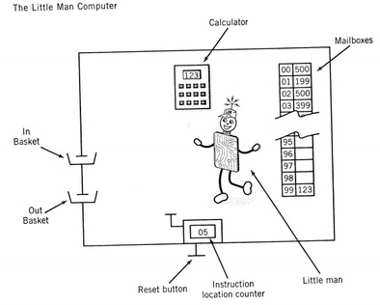

d)

This program will take in two inputs from the user, add them and display the result back to the user

//this starts the program

Start

//This takes in an input from the user

901

//This stores the input into memory location ‘07’

307

//This reads in another number

901

//This adds the first number to the second

107

//This outputs the result to the user

902

//This tells the computer to take a break

000

END

# Question 2

a) (i) A queue is the process of first in first out. This means whatever was first added to a job list would be first to deal with

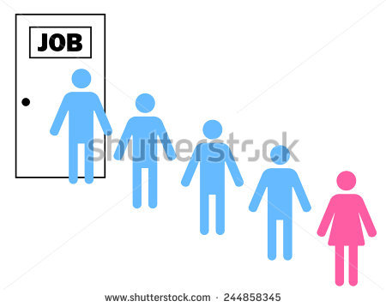

(ii) A stack is the process of last in first out. It is putting the new tasks on top on everything else that needs to be done.



(iii) A heap is a structure where the higher values have higher access than lower. For example, Private patient in hospitals tend to have higher priority than public, such as CEO of Google in comparison to a school teacher.



(b) The process of the **Job Scheduler** is to make sure every task is done in the most apprioate way and most efficient way possible. It makes sure no part of the process is left unchecked.



c) 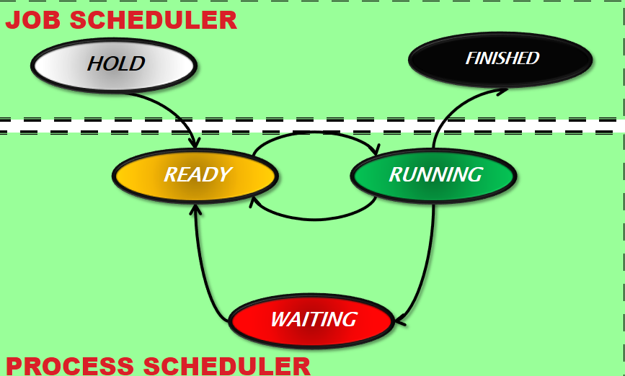

Hold means grab a process and hold it.

Ready means the programme is ready to run.

Running means the programme is being executed

Waiting means it is waiting for some reason (for example input from the user)

Finished means it is finished the programme.

d)

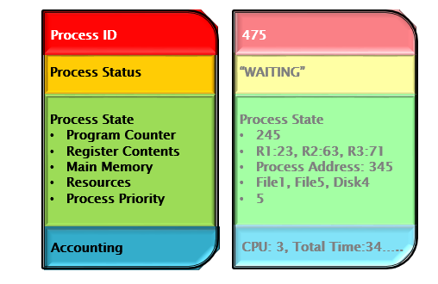

Process ID is the id giving to that programme while it is in the computer, which is unique from other programmes.

Process status is the status the programme is currently within the job scheduler, for example ready or waiting

Process states include sub-components which tell it where it came from, what it contains, what step it is on, what does it need and the priority of the programme itself.

Accounting takes the time spent on the programme, data stored, process number and register number, as well as time on everything else in the programme itself.

# Question 4

**a)**

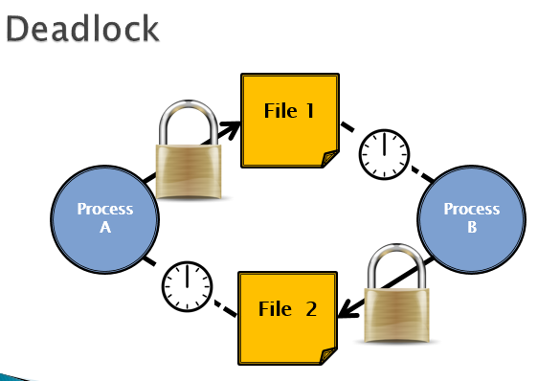

1. Deadlock on file requests
2. Deadlock in databases
3. Deadlock in dedicated device allocation
4. Deadlock in multiple device allocation

**b)** The File Manager

* + Keeps track of where files are stored
  + Determines how the files are stored
  + Follows operating system file allocation policies
  + Uses available storage space efficiently for files
  + Creates a record/log of all file usage
  + Allocates a file to a user if is free, and if they are permitted access to it.
  + De-allocates file when user finished with it.

**c)**

i)

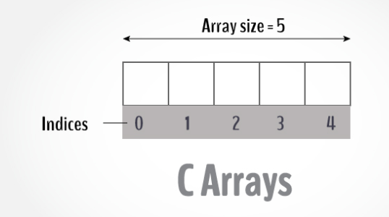

Contiguous storage is storage that follow one after another. This would be multiple inputs within one block that are separated but each member within the block itself.

ii)

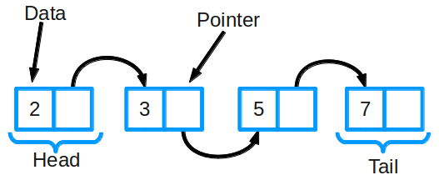

Non-Contiguous storage is files stored in different areas completely, but may be joined together in another way. For example Linked list.

iii) Indexed storage are storage that could be storage anywhere, but have their address stored on a different file in a sorted order. A example would be a table of contents within a book.



**d)**

The access control matrix is the permission given to a group of people of what they can do with a file. In DOS, it is either you or a group of people and in Linux, it is either the user, people who are part in the same group or everyone else who have access to the system. It could be reading, modifying, or executing the programme. That is what the access control matrix is.

